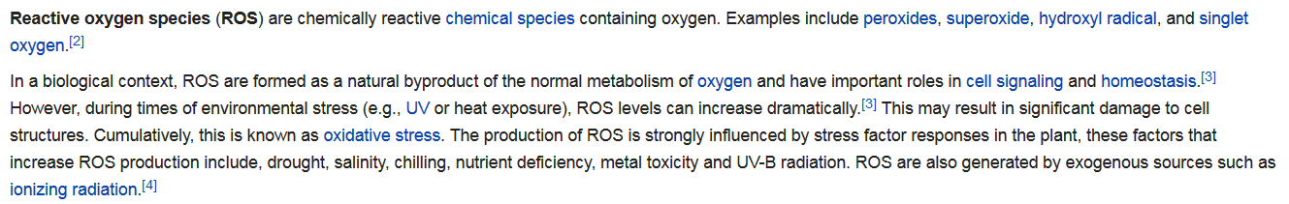

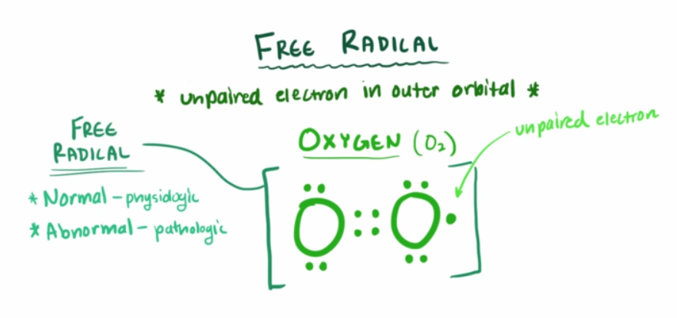

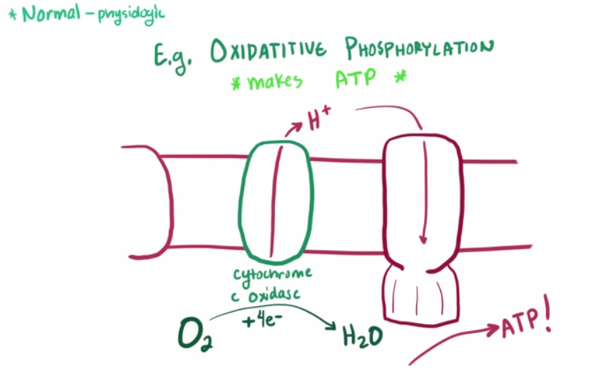

During the production of ATP by your mitochondria via oxidative phosphorylation, O2 is converted to water (by gaining 4 electrons) as the by product, however in some instances this does not happen all the way and anything less than 4 electrons make O2 as different forms of free radicals.

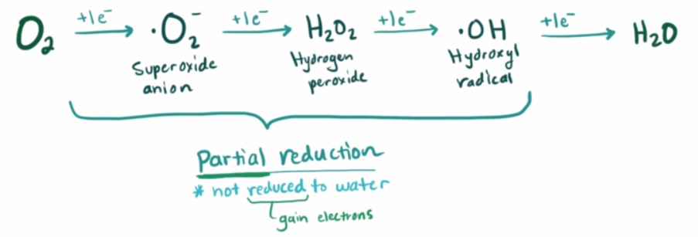

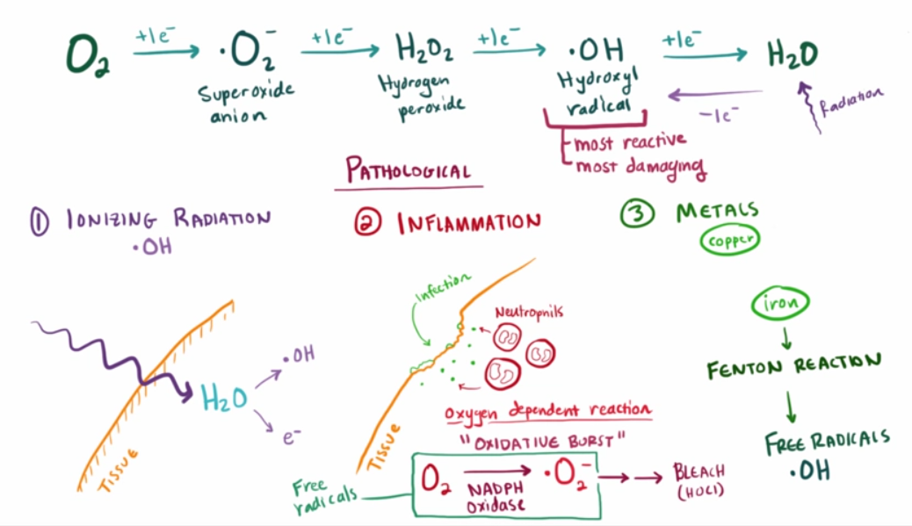

One of the ways free radicals wreck havoc is damaging your cells (membrane) by stealing an electron, which starts a chain reaction within the cell membrane as they steal an electron from the neighboring cell to make up for the lost electron, which does the same with its neighbor.

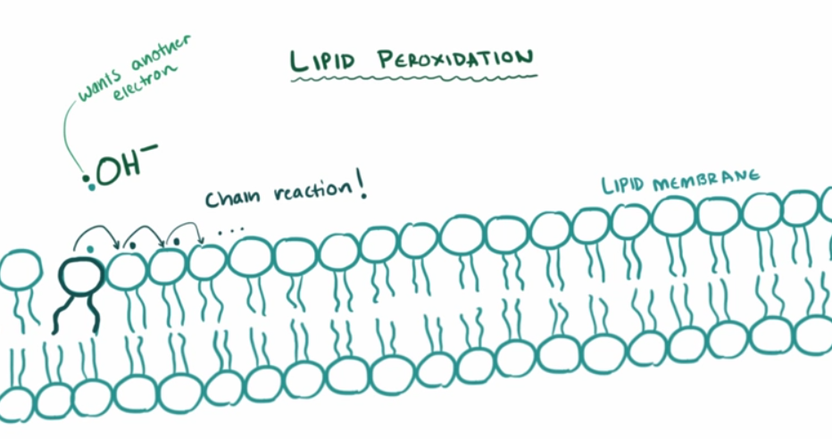

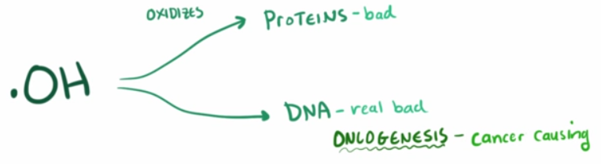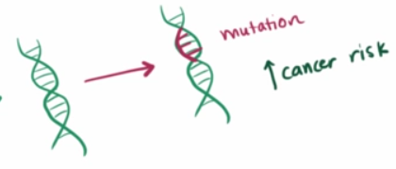

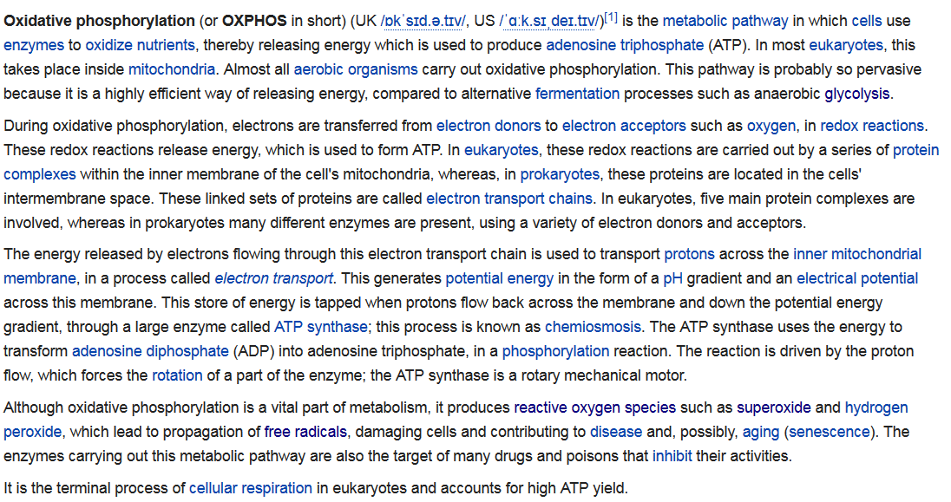

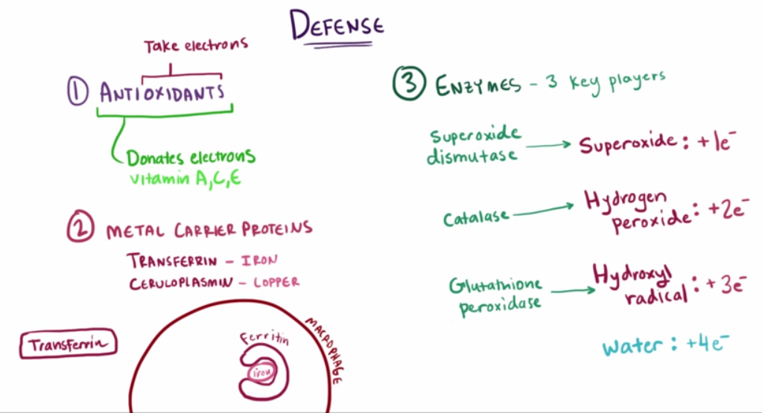

Vitamins and other Antioxidants work by donating electrons, which can be taken up by the free radicals so they don’t go around stealing electrons from cells/proteins/DNA etc thereby reducing/eliminating free radical damage!

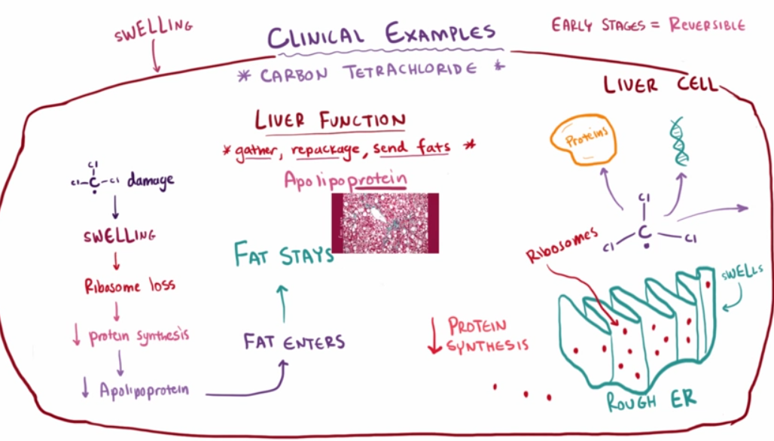
Fatty liver is caused because of free radicals in the liver, which stop Apolipoprotein from doing their job of receiving, packaging and sending the fats received from the liver. This is done by swelling in the endoplasmic reticulum of the liver, which causes the loss of Ribosomes which reduces protein sysnthesis therefore Apolipoprotein levels drops so fat stays put!!

Free Radicals and Reactive Oxygen
http://www.vivo.colostate.edu/hbooks/pathphys/topics/radicals.html

Reactive Oxygen Species (ROS)
http://www.biology-pages.info/R/ROS.html
